Coinage Reference
Jay Luker, jay.luker@gmail.com
Research & Practice in Software Architecture
Tufts University, Spring ‘08
The OpenURL standard enables a user who has retrieved an article citation, for example, to obtain immediate access to the "most appropriate" copy of that object through the implementation of extended linking services.
- NISO Standard - http://www.niso.org/standards/standard_detail.cfm?std_id=783
- SFX Link Resolver - http://www.exlibrisgroup.com/category/SFXOverview
- Auto-discovery - http://www.ariadne.ac.uk/issue43/chudnov/
COinS (ContextObjects in Spans) is a simple, ad hoc community specification for publishing OpenURL references in HTML.
- OpenURL COinS - http://ocoins.info/
- OpenURL Referrer Extension - http://nj.oclc.org/openurlref/
MESUR is a project underway at Los Alamos National Laboratory to create MEtrics derived from Scholarly Usage of Resources.
- MESUR Home - http://mesur.org/MESUR.html
REST = REpresentational State Transfer. Resource-Oriented Architecture is a way of turning problems into RESTful web services.
- Roy Fielding's Dissertation - http://www.ics.uci.edu/~fielding/pubs/dissertation/top.htm
- RESTful Web Services Book - http://www.oreilly.com/catalog/9780596529260/
Other Stuff
- OCLC Resolver Registry - http://www.oclc.org/productworks/urlresolver.htm
- LibX - http://libx.org
- Zotero - http://zotero.org
- LibraryThing for Libraries - http://www.librarything.com/forlibraries/
- Django: Python Web Framework - http://djangoproject.org
- jQuery: JavaScript/AJAX library - http://jquery.com

Collector diagram:
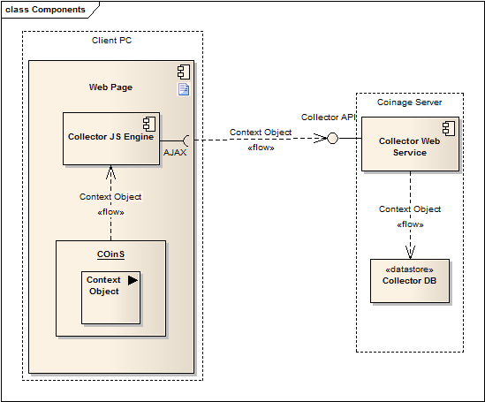
CoinOp diagram
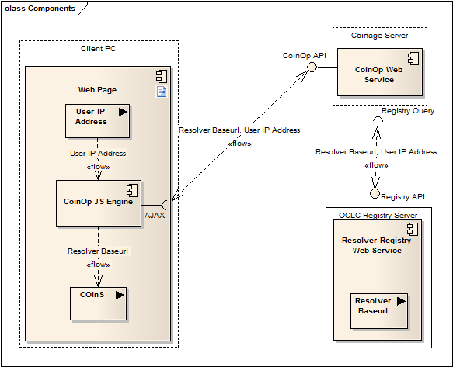

Conjure diagram
